# Ideation Phase

**Define the Problem Statements**

|  |  |
| --- | --- |
| Date | 19 September 2022 |
| Team ID | PNT2022TMID11825 |
| Project Name | Project - NEWS TRACKER APPLICATION |
| Maximum Marks | 2 Marks |

**Customer Problem Statement Template:**

Create a problem statement to understand your customer's point of view. The Customer Problem Statement template helps you focus on what matters to create experiences people will love.

A well-articulated customer problem statement allows you and your team to find the ideal solution for the challenges your customers face. Throughout the process, you’ll also be able to empathize with your customers, which helps you better understand how they perceive your product or service.

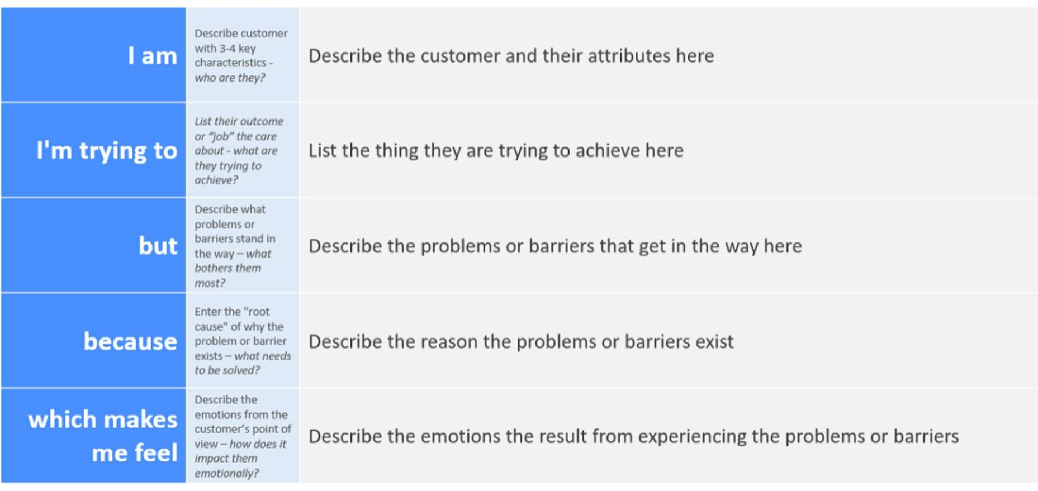

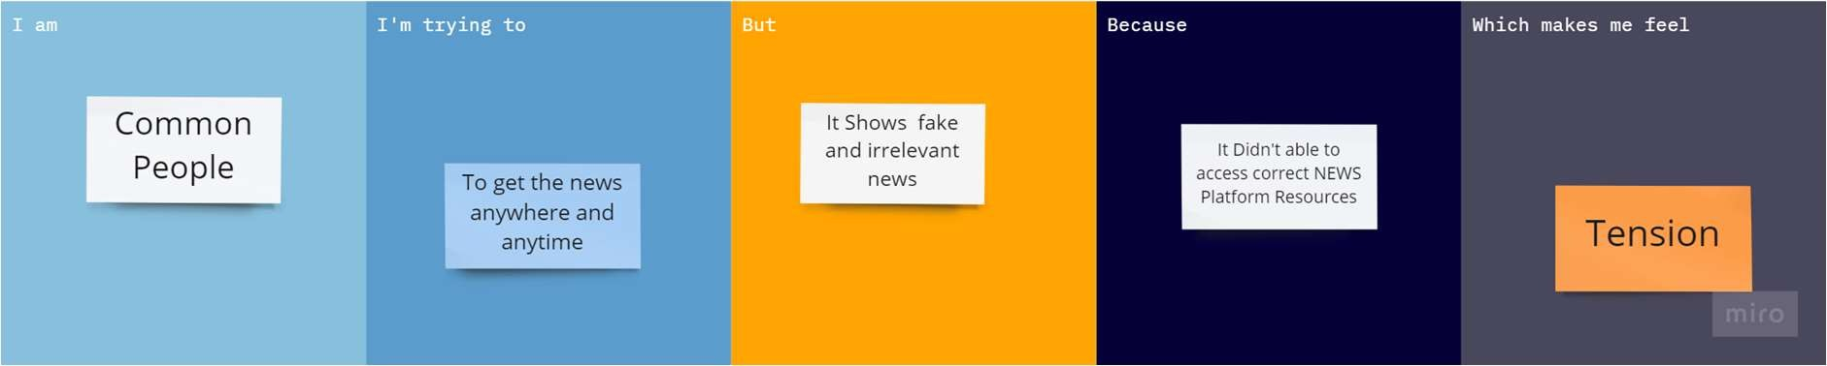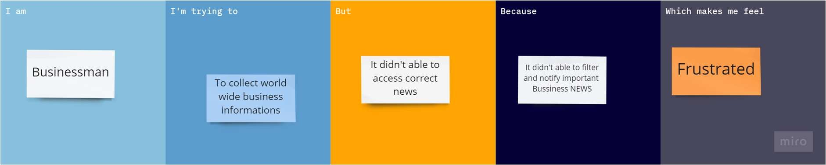

|  |  |  |  |  |  |
| --- | --- | --- | --- | --- | --- |
| **Problem Statement**  **(PS)** | **I am (Customer)** | **I’m trying to** | **But** | **Because** | **Which makes me feel** |
| PS-1 | Common People | To get the news anywhere and anytime | It Shows fake and irrelevant  news | It Didn't able to access correct NEWS Platform Resources | Tension |
| PS-2 | Businessman | To collect world | It didn't | It didn't able to filter | Frustrated |
|  |  | wide business | able to | and notify |  |
|  |  | information | access | important Bussiness |  |
|  |  |  | correct | NEWS |  |
|  |  |  | news |  |  |
| PS-3 | Local | To access local | It didn’t | Because of that most of the native peoples didn’t share the information in  news platform app | Unawareness |
|  | People | news instantly | access |  |
|  |  |  | the local |  |
|  |  |  | news |  |
| PS-4 | Foreign People | To access local news as well as global news in  their language | But This option is not  available | They didn’t understand the news from that  platform | Confussed |
| PS-5 | Common | The News | But Many | They didn’t | Confussed |
|  | People | article phases | News | understand the |  |
|  |  | are very easily | headlines | news clearly from |  |
|  |  | understandable | and | that news app |  |
|  |  | by using often | articles |  |  |
|  |  | usable words | are used |  |  |
|  |  |  | rare |  |  |
|  |  |  | verbal |  |  |
|  |  |  | phases |  |  |